

SYSTEMS DIVISION

PROJECT CHARTER

Disaster Recovery Phase 1
Document #3227
WR #3227

April 8, 2005

Prepared by:
Maureen Smith

Approved by:

Curt Schumacher
Systems Division

APPROVED

CONFIDENTIAL

Disaster Recovery Phase 1 – Project Charter Distribution List

Staff

Tom Busch
Jeff Caldwell
Steve Chodash
Karen Christiansen
Angela Davis

Sandy Elliott
Todd Furney
Linda Gerdes
Chris Hield
Ed Horvath
Dave Hultquist
Keith Kiley
Eva Kolasinski
Tom Lynch
Jim Neceda
Mark Novak
Dennis Paradiso
Don Patton
Bob Peterson
Larry Pfaffenbach
Bobbie Piwnicki
John Rittner
Gautam Roy
Brad Samuels
Dave Schmitz
Curt Schumacher
Patrick Sexton
Joanne Moffic-Silver
Eileen Smith
Jeff Smith
Maureen Smith
Joe Ulowetz
Stella Ulyanov
Ravi Vazirani
Matt Vliet
Tim Watkins
Dave Wegener
Margaret Williams
Deborah Woods
Mark Woyna
Don Zagorski
Carole Zylius
Disaster Recovery Phase 1

Table of Contents

1. Goal 1
2. Objective 1
3. Business Case 1
4. Strategy 1
5. Tactics Statement 1
6. Project Scope and Approach 1
7. Assumptions and Issues 2
8. Risk/Exposure 2
9. Cost Analysis 2
10. Benefits 2
11. Environmental Analysis 3
12. Schedule and Dependency Constraints 3
13. Resource Skill Needs 3
14. Product Research 3

Disaster Recovery Phase 1
PROJECT CHARTER

Goal
The goal of the Disaster Recovery Phase 1 project is dual faceted. The implementation of a Disaster Recovery Site will initially preserve the market place for exclusive and single listed products during a disaster. In addition, it will satisfy the Security and Exchange Commission’s requirements for Disaster Recovery.

Objective
The objective of this project is to provide a fully functional and tested Disaster Recovery location for the CBOE to run its core systems, along with formally documented processes and procedures for the initialization and ongoing maintenance of the facility.

Business Case
CBOE currently has one primary office space that provides the location for its data center, trading floor and staff. For several years the SEC has recommended the implementation of a remote site to provide backup to that facility in the event that a major disruption in service occurs at its primary location. The IT organization has gained approval and funding from the Board of Directors to develop and implement the recommended site to support a recovery location for a portion of its mission critical systems.

Strategy
The strategy for this project is to:
- Enhance the CBOEdirect Block Trades Functionality
- Acquire 4000 sq. ft. of Data Center space from a Hosting Facility
- Implement the Systems Infrastructure
- Connect External Interfaces
- Test and Ready the Environment

Tactics Statement
This project will be developed following the standard Systems Development Methodology.

Project Scope and Approach
The scope of the project is a facility supporting Exclusive Listed (ELO) and Single Listed (SLO) products using the CBOEdirect trading environment on a next day recovery basis.

This CBOEdirect electronic trading disaster recovery facility will require minimum Operations staff and assumes that multiple listed equities and indexes are traded at other options markets during the period where CBOE’s main facility was unavailable. Additionally, a Block Trade Facility would be employed to accommodate trades that are normally handled in open outcry. Included in the electronic trading environment is connectivity and processing for:
- TPF, TIPS, COMPASS, Host Gateway
- MVS – supporting facilities to TPF and CBOEdirect
- Firms connectivity through FIX, CMI, COMPASS
- CTM-R and CTM-I
- System Change Management Facilities

The environment will also include access to the mission critical software required by supporting environments in order for CBOE to be viable during a disaster situation. The following supporting environments are anticipated as required:
- Accounting Systems – Great Plains software, Ceridian, Integrated Billing
- Human Resources Systems – PeopleSoft
- Legal
- Internet Marketing
- Regulatory Systems
- Membership
- Corporate LAN – user access needs to be determined (VPN)?

Assumptions and Issues
- It is assumed the SEC will approve rules that would allow for large and complex trades under certain conditions to be matched through phone communication and submitted to CBOEdirect for processing via the enhance Block Trades functionality.
- It is assumed that the phase 1 disaster recovery environment would need to be able to minimally sustain a one-month outage. If the outage went longer than one month, then additional measures would need to be adopted (i.e. backup pulled from Escrow Storage).

Risk/Exposure
There appears to be no significant risk to current trading floor systems or business risks.

Cost Analysis

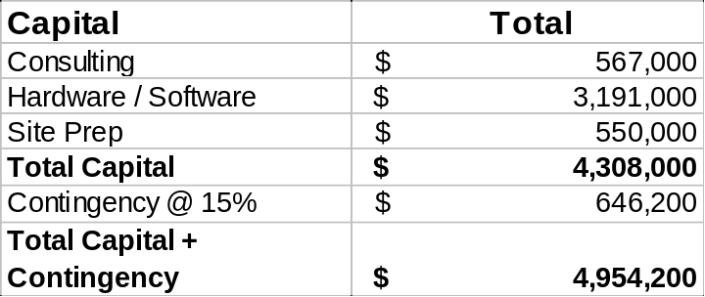
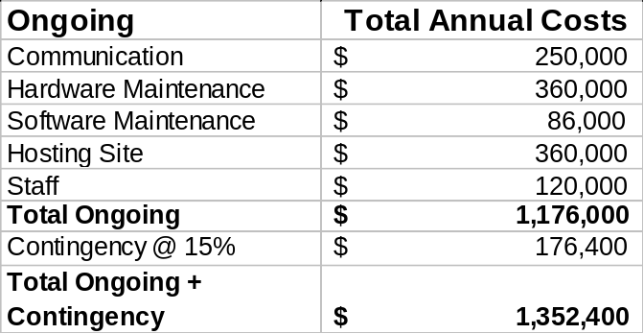

Benefits
The benefit of this project is the implementation of a disaster facility that will initially preserve the market place for exclusive and single listed products during a disaster.

Environmental Analysis
Detail Diagrams and descriptions are available in the Requirements Specification.

Schedule and Dependency Constraints
This project is dependent on:
- The acquisition of an offsite facility.
- The acquisition, installation and testing of required hardware/software.
- Completion of the Disaster Recovery - Block Trades Project WR #3217.

The following is a tentative schedule:
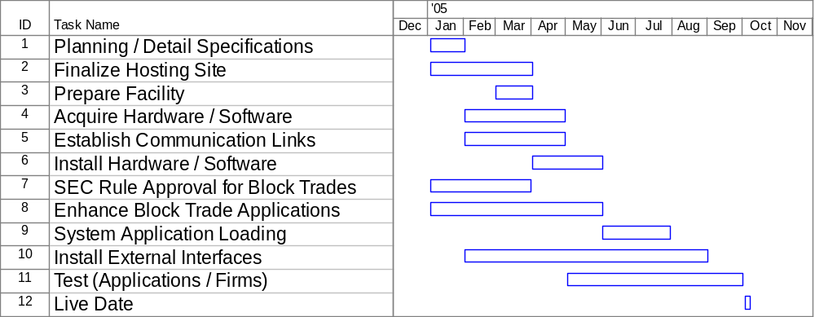

Resource Skill Needs
In-house resources have the skills necessary to complete the Disaster Recovery Phase 1 Project.

Product Research
No further investigation of products or vendors will be necessary to complete the Disaster Recovery Phase 1 Project.

